PGE 392K In Class Assignment

Nov 10, 2020

1. Adapt your 1D code to calculate the Courant matrix by computing the velocity using Darcy’s law and the pressure field. I suggest you have a function file that computes the velocity and Courant # when send the two adjacent grid blocks, vector of pressures, and reservoir/fluid/numerical properties
2. Adapt your code for 2D problems. Specifically, adapt your function file to compute arrays to calculate the Courant, , and Dimensionless dispersion, , matrices in 2D. You may want to copy the structure of the for loop to work for Transmissibility matrix.
3. Test your code for a 3x3 grid with an injector in the bottom left corner (block #1) and producer in upper right corner (block #N=NX\*NY). The pressure field at steady state has already been computed and is provided in the text file, ‘Pss1.txt’.

The permeability and porosity are homogeneous and isotropic, 100 mD and 20%, respectively. The viscosity is 1 cp. The reservoir is 1200 ft by 1200 ft and the thickness, h=20 ft. Fluid is injected at 5000 scf/day and the injected concentration is 1.0. Fluid is produced at 5000 scf/day. The Dispersion coefficient, D = 16 ft2/day. Use a timestep of t = 10 day.

Calculate the T,  and  matrices and then plot the concentration of the producer with time.

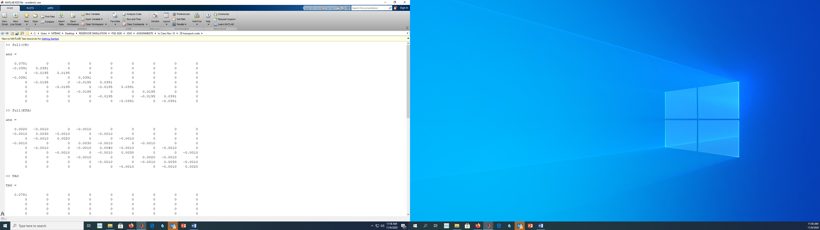

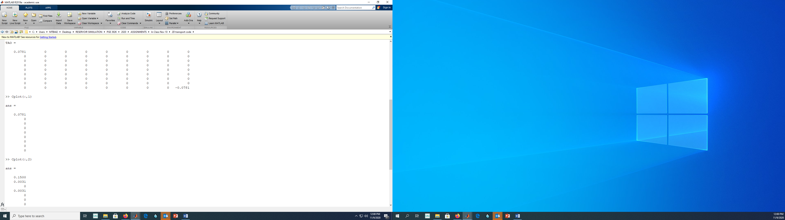

 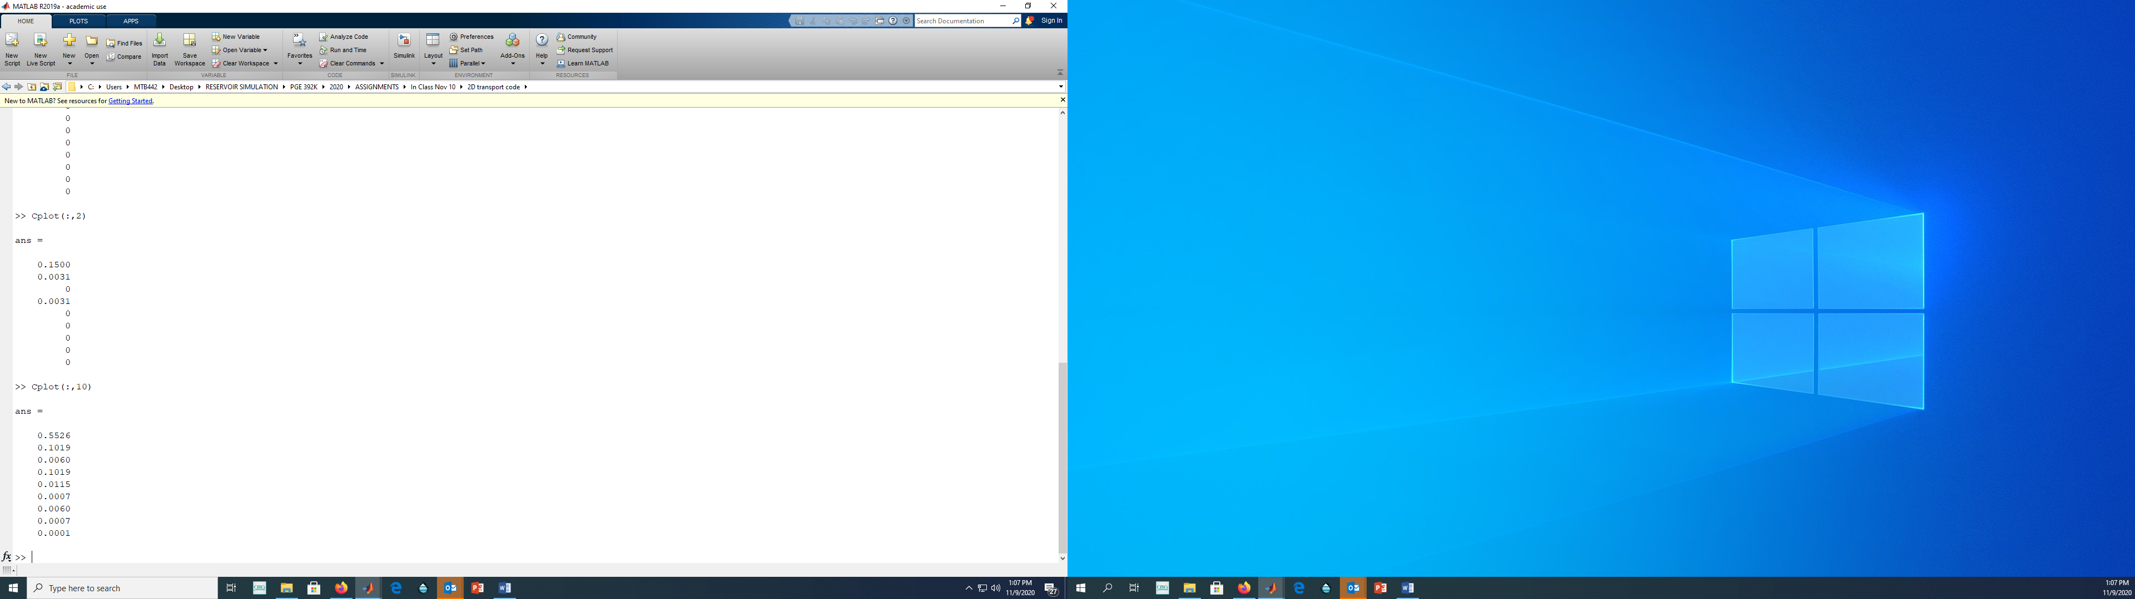 

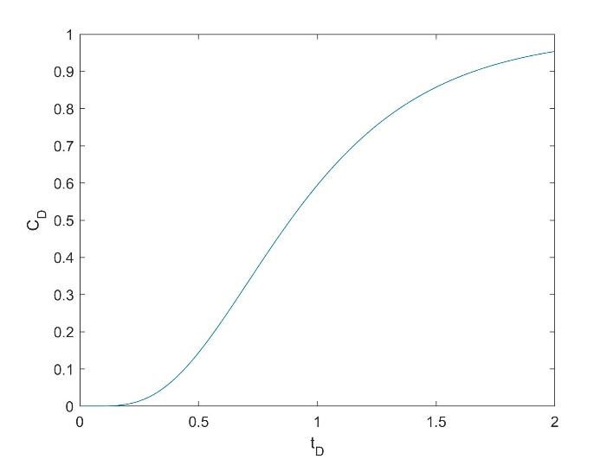

1. Repeat for a 30 x 30 grid but use a timestep of t = 0.1 day. The pressure field at steady state has already been computed and is provided in the text file, ‘Pss2.txt’. Plot the concentration of the producer with time and make filled contour plots of the concentration field at tD = 0.1, 0.5, 1.0 PV

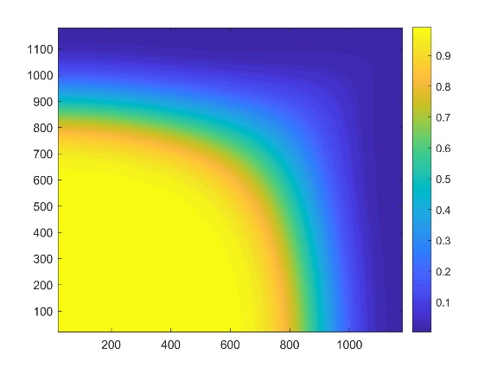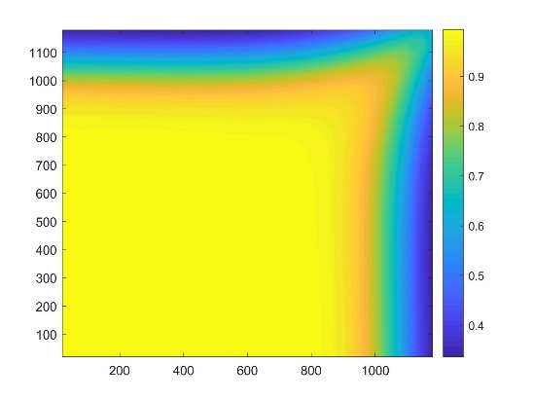

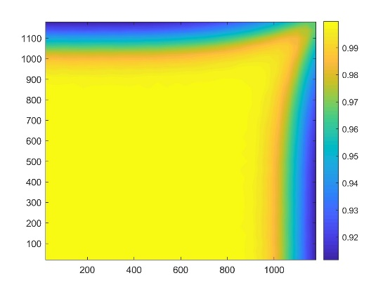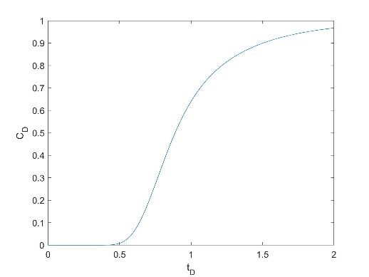

1. Repeat, but only inject the tracer component for 0.05 pore volumes.

